Marisleysis De La Cruz

**IsSorted**: In this graph, it can be seen that the running time increases as number of elements increases meaning that it takes longer for the code to run. This is because the code has to iterate through more elements to check if the list is sorted or not.

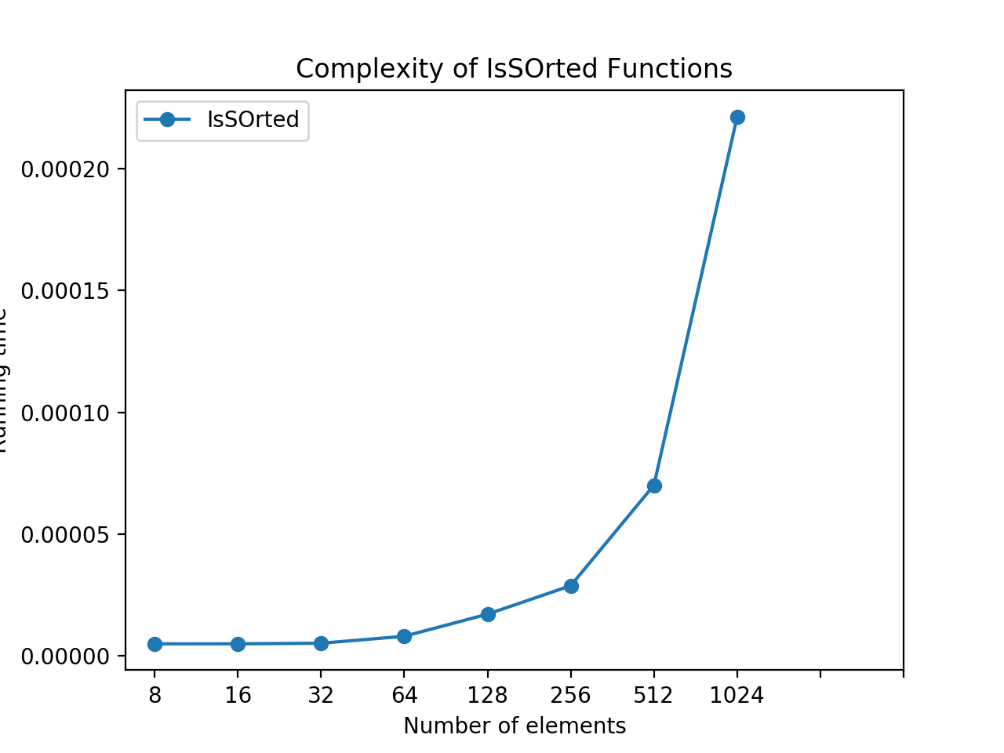

**Linear and Binary Search**: In the linear search, as the number of elements increases the running time increases because it has to search through more elements to find the element that matches the key. The binary searches in recursive and iterative form are similar, but the iterative code is a little faster when the number of elements reaches 128. This is because the recursive function has to call itself while the iterative code just keeps going through the loop continuously.

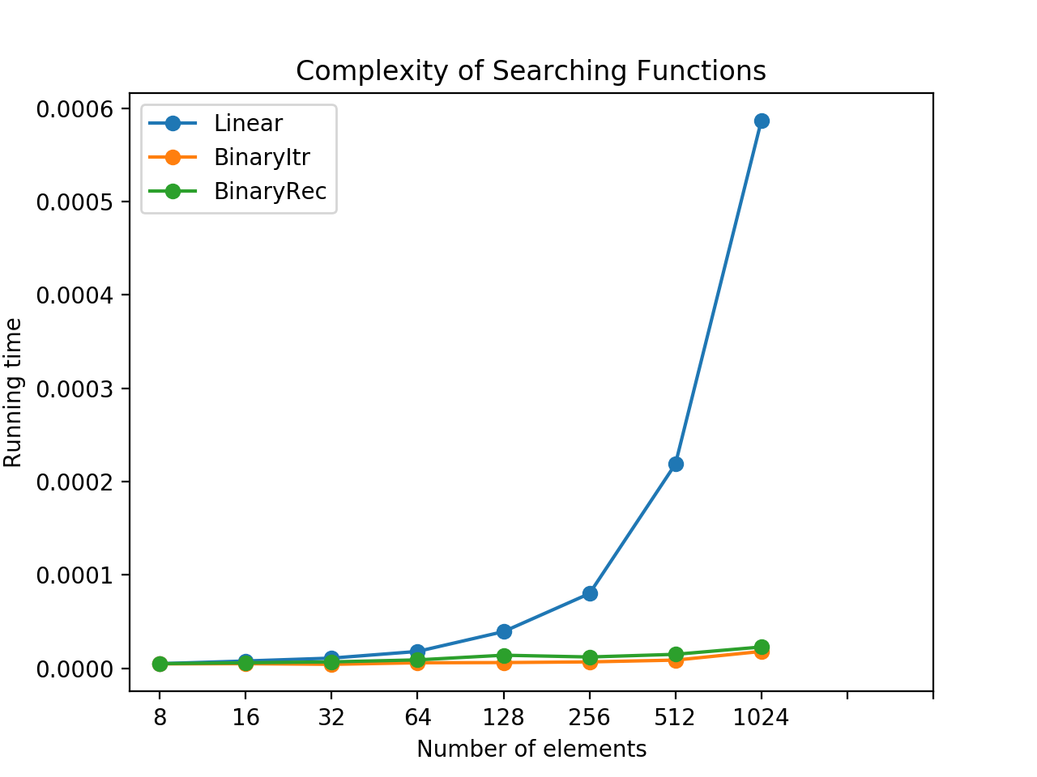

**Bubble and Counting:** In this graph, the running time for the counting function is constant no matter how many elements it is dealing with. It’s running time stays at about 0.17 seconds and this is because the first thing counting sort does it take the biggest element and makes it the range of the list. This saves a lot of time. The time for bubble function remains constant until it reaches 256 elements, in which the running time increases from 0.5 seconds to 1.7 seconds. After 512 elements, the increment in running time is greater. This is due to the fact that bubble sort swaps the elements next to each other until it goes through the entire list, many iterations are needed.

